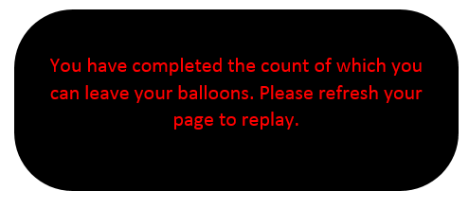

You have completed the count of which you can leave your balloons. Please refresh your page to replay.